Activities 6 Crossword
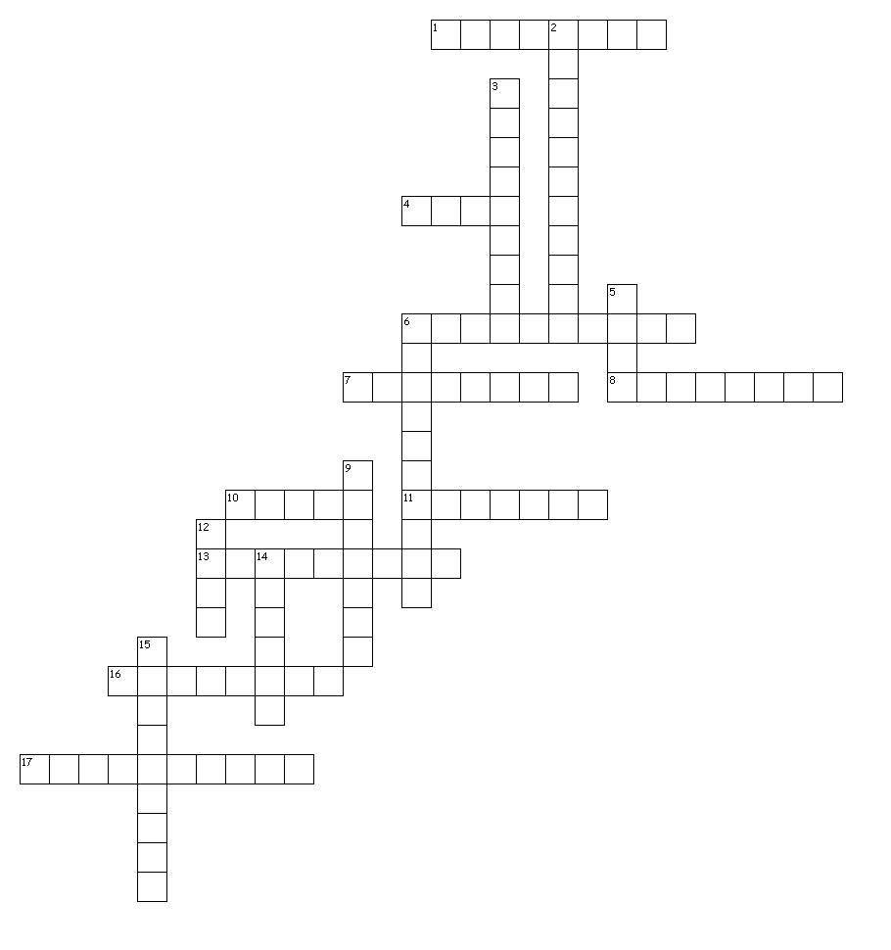

Across
1. softball
4. boat
6. bungiejump
7. baseball
8. Fishing Golf Gymnasium Hike Hockey Jog Karate martial arts Iceskate Rollerskate skateboard Skydive Snow board Soccer soccer
10. scuba
11. bowling
13. Waterpolo
16. boatride
17. volleyball
Down
2. bicycleride
3. wrestling
5. surf
6. basketball
9. Camping
12. swim
14. tennis
15. horseride

